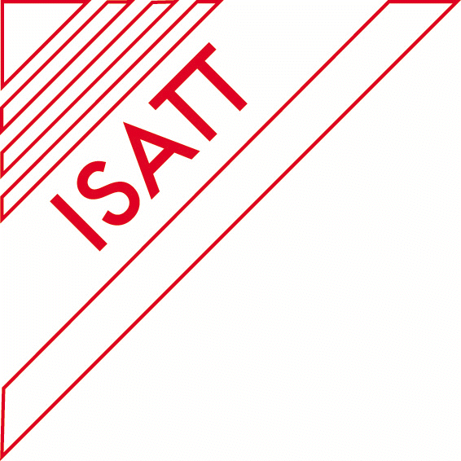

STUDENT AND FACULTY TRAVEL BURSARIES
For Regional Conferences

Several ISATT-sponsored bursaries of varying amounts are available. They are budgeted for each regional conference. £1,000 is earmarked for student and faculty to travel to each ISATT’s regional conferences in 2024. These bursaries allow for the greater participation of research students and members in ISATT’s regional conferences. Due to the confidential nature of the applications, the bursary programme is coordinated by the Treasurer in consultation with the Chair and Secretary.

ISATT Travel bursaries – Criteria for regional conferences (for 2024 Brazil and Greece)

- INDISPENSABLE CONDITIONS:
  - For students: ISATT membership + paper accepted + letter of support
  - For faculty: ISATT membership + paper accepted

All eligible applicants – students and faculty alike are invited to apply for one of the below travel bursaries:
  - For students: 2 bursaries available, each £300
  - For Faculty members: 2 bursaries available, each £200

Unused Travel bursary funding can be re-allocated to students or faculty members as appropriate.

In each group, applicants are ranked on the basis of the following criteria – to be applied in the sequence indicated:

- anticipated expenditure on travel and accommodation, as indicated by the applicant in the application form
- assignment of ISATT travel bursary in the past (priority for applicants who did not receive a bursary before)
- professional status as to sector(s), full-time equivalent per sector and function(s): priority for applicants who work only in education and/or research and for lower functions. This implies that students have priority over faculty.
- availability of other funding (besides personal income) for covering conference costs: priority for applicants who can rely only on personal income. (Item to be added in the application form.)

Applications for the Brazil and Greece regional conference must be received by the ISATT Administrator, Daniela Hotolean d.hotolean@reading.ac.uk , by the 9th August 2024
Arrangements for reimbursement will be made at the conferences on presentation of ID and receipts for travel/accommodation. Receipts must meet the approval of ISATT’s Treasurer and the auditor of ISATT’s accounts.

TRAVEL BURSARY APPLICATION FORM

Name: Email:

Address:

Region:

Please check applicable boxes (X):

Student: Faculty:

Letter of Support (if applicable):

Amount Requested: Availability of other funding:

Details on ALL actual paid employment: sector/ full time equivalent/function

Personal Justification Statement:

Anticipated Expenditures

Travel Accommodations

Preferred method of reimbursement:

Bank transfer: via PayPal account:

I understand that I must show original receipts & ID to receive reimbursement for my travel award. Receipts must meet the approval of ISATT’s Treasurer and the auditor or ISATT’s accounts.

Signature: _______________________________ Date: ____________________________

